NAWD Action Item #7: Make and Wear a T-shirt
February 11, 2015 by mixinminao
Good Adjuncts:
For those of you who like something more visual and durable (It’s not like after Feb. 25th the skies will cleave open and adjuntification will disappear and birds will sing), a T-shirt may be the better way to go. I know there are a few designs already out there, but this is one that we came up with at Adjunct Crisis.
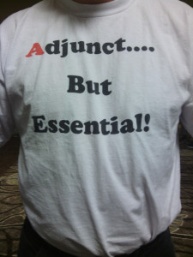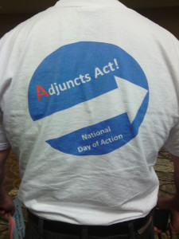
If you want, I can send the jpegs of the designs so you can make one for yourselves. For any San Diego Mesa College or Southwestern Community College folks who want a shirt, I’ll be contacting you via campus email.
Geoff Johnson
A Good and Sartorially Splendorous Adjunct

